深 圳 大 学 实 验 报 告

课程编号： 2801000049

课程名称： 机器学习

实验项目名称： 实验1 Introduction and Regression

学院： 电子与信息工程学院

专业： 电子信息工程

指导教师： 麦晓春

报告人： 卢嘉伟 学号： 班级： 文华

实验时间： 2025.2.24 - 2025.3.31

实验报告提交时间： 2025.3.31

教务部制
1. Experimental Purposes
(1)Be familiar with the principles and implementation of linear regression and ridge regression models.
(2)Understand the impact of different housing features on price prediction through exploratory data analysis and correlation analysis.
(3)Learn how to apply 10-fold cross-validation to evaluate model performance and optimize hyperparameters in ridge regression.
(4)Gain experience in handling real-world datasets, including missing value detection, data visualization, and performance evaluation using Mean Squared Error (MSE).
(5)Improve practical skills in using Python and machine learning libraries such as Scikit-learn, Pandas, Seaborn, and Matplotlib for data analysis and regression modeling.

2. Experiment Contents and Process
2.1 Experiment 1
2.1.1 Experimental Contents
(1)Data Analysis & Preprocessing:
A.Checking for missing values and handling data inconsistencies.
B.Conducting exploratory data analysis (EDA) to understand feature distributions and correlations.
(2)Model Implementation & Training:
A.Implementing Linear Regression and Ridge Regression models.
B.Splitting the dataset into training (90%) and testing (10%) subsets.
C.Using 10-fold cross-validation to optimize model performance.
(3)Model Evaluation & Performance Metrics:
A.Computing the Mean Squared Error (MSE) for both training and testing sets.
B.Comparing actual vs. predicted house prices to assess model accuracy.
2.1.2 Methods
(1)Machine Learning Models & Algorithms
Linear Regression: A fundamental regression model that estimates the relationship between input features and the target variable using a linear equation.
Ridge Regression: An extension of linear regression that incorporates L2 regularization to prevent overfitting. The optimal regularization parameter (α\alphaα) is selected using 10-fold cross-validation.
(2)Experimental Techniques
Data Splitting: The dataset is divided into a training set (90%) and a testing set (10%) to ensure reliable model evaluation.
10-Fold Cross-Validation: Used to validate model performance and determine the best hyperparameters.
Data Visualization: Histograms, scatter plots, and correlation heatmaps are employed to analyze data distribution and feature relationships.
Performance Metrics: The Mean Squared Error (MSE) is used to quantify prediction accuracy and compare different models.
2.1.3 Data Collection, Preprocessing and Analysis
(1)Data Collection
Data source:
https://www.kaggle.com/datasets/altavish/boston-housing-dataset?resource=download
The dataset consists of 506 samples with 13 feature variables describing various aspects:
CRIM： Urban per capita crime rate
ZN： The proportion of land parcels larger than 25000 square feet classified as residential land
INDUS： Proportion of non retail business in each town
CHAS： Charles River dummy variable (if=1, it is a river; if=0, it is not a river)
NOX： Nitric oxide concentration (per million)
RM： The average number of rooms per residential unit
AGE： The proportion of self occupied houses built before 1940
DIS： Weighted distance to five employment centers in California
RAD： Accessibility index for radial highways
TAX： Full price property tax per $10000
PTRATIO： The ratio of students to teachers in urban areas
B: 1000 (Bk-0.63)², where Bk is the proportion of black people in urban areas
LSTAT： Proportion of low social class population (%)
MEDV： The median price of a self occupied house in units of $1000
The target variable is MEDV.
- Preprocessing&Analysis
Missing Value Analysis: Checked for null values to ensure data completeness. No missing values were found.
Exploratory Data Analysis:
Distribution Analysis: The target variable (house prices) follows a slightly skewed distribution.
Feature Correlation: Some features, such as the average number of rooms per dwelling, show strong positive correlations with house prices, while others, such as crime rate, exhibit negative correlations.
Feature Scaling: Since regression models are sensitive to feature magnitudes, all features were normalized where necessary.
2.1.4 Experimental Results and Analysis
(1)Model Performance
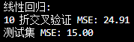
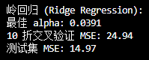
Linear Regression:
The model performed well but showed some variance in predictions.
The cross-validation error was higher than expected, suggesting the sample set has a small quantity.
Ridge Regression:
By optimizing the hyper-parameter (α), the model achieved better generalization.
The test set MSE was lower than that of Linear Regression, indicating improved robustness.
(2)missing values
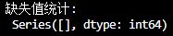
There is no missing value.
- Exploratory data analysis
Plot the distribution of the target variable.
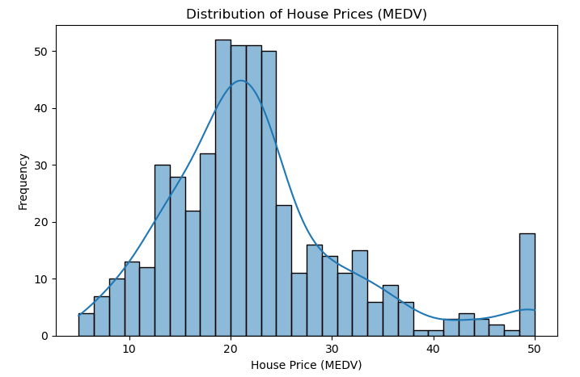
Create a correlation matrix that measures the linear relationships between the variables and plot the correlation matrix.
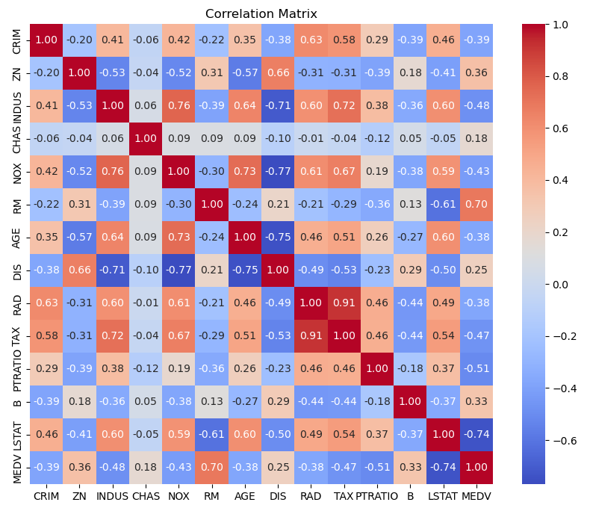
Plot a scatter plot between the original house price and predicted house prices
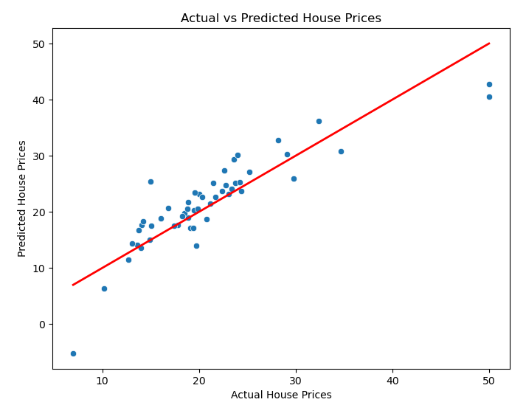
The scatter plot of actual vs. predicted prices showed that both models captured the trend, but Ridge Regression demonstrated a more balanced performance.
Some outliers were observed, which might have contributed to the prediction errors.
(4)Conclusion
Ridge Regression outperformed Linear Regression by reducing overfitting and improving prediction accuracy.
Feature importance analysis suggested that attributes like the number of rooms per dwelling (RM) and the percentage of lower-status population (LSTAT) had a significant impact on house prices.
Further improvements could be achieved by incorporating non-linear models, such as decision trees or neural networks.
3. Discussion and Conclusions
The difficulties you met during experiments and how did you tackle them. Special parameter design. What do you learn from experiments, and so on.
- Challenges and Solutions
A.Multicollinearity Among Features
Problem: Some features in the dataset exhibited high correlation, leading to multicollinearity, which can negatively impact linear regression models.
Solution: I analyzed the correlation matrix to identify highly correlated features and used
B.Prediction Errors and Outliers
Problem: Some predictions deviated significantly from actual values, likely due to outliers in the dataset.
Solution: I visualized the residual errors and potential outliers using scatter plots. Although outlier removal could improve model performance, we retained them to reflect real-world conditions. Future work could explore robust regression techniques.
- Special parameter design
Choosing the Optimal Regularization Parameter (α) for Ridge Regression
The choice of α significantly affects Ridge Regression’s performance, and selecting a suboptimal value could lead to underfitting or overfitting. I used 10-fold cross-validation over a range of α values to determine the optimal parameter. This ensured better generalization on unseen data.
(3)Key Learnings from the Experiment
A.Feature Importance and House Price Prediction
Certain features, such as the number of rooms per dwelling (RM) and the percentage of the lower-status population (LSTAT), strongly influence house prices.
Understanding feature importance helps in selecting relevant variables for better model performance.
B.Impact of Regularization
Ridge Regression helped stabilize the model by reducing variance and preventing overfitting.
Compared to standard Linear Regression, Ridge Regression provided lower test set MSE, confirming the benefits of regularization in high-dimensional data.
C.Bias-Variance Tradeoff
Linear Regression had higher variance, leading to overfitting on the training set.
Ridge Regression reduced variance by slightly increasing bias, but ultimately led to better better generalization on unseen data.

Appendix
Appendix A:Database
Data.csv

Appendix B:Experimental code
exp1_LuJiaWei_2023280113.py
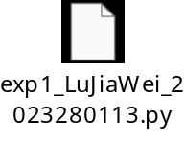
深圳大学学生实验报告用纸

指导教师批阅意见：

成绩评定：

指导教师签字：
年 月 日
备注：
注：1、报告内的项目或内容设置，可根据实际情况加以调整和补充。
2、教师批改学生实验报告时间应在学生提交实验报告时间后10日内。

